COAL Lab Task 11
(Whole Code in the end of doc)
Task 1:
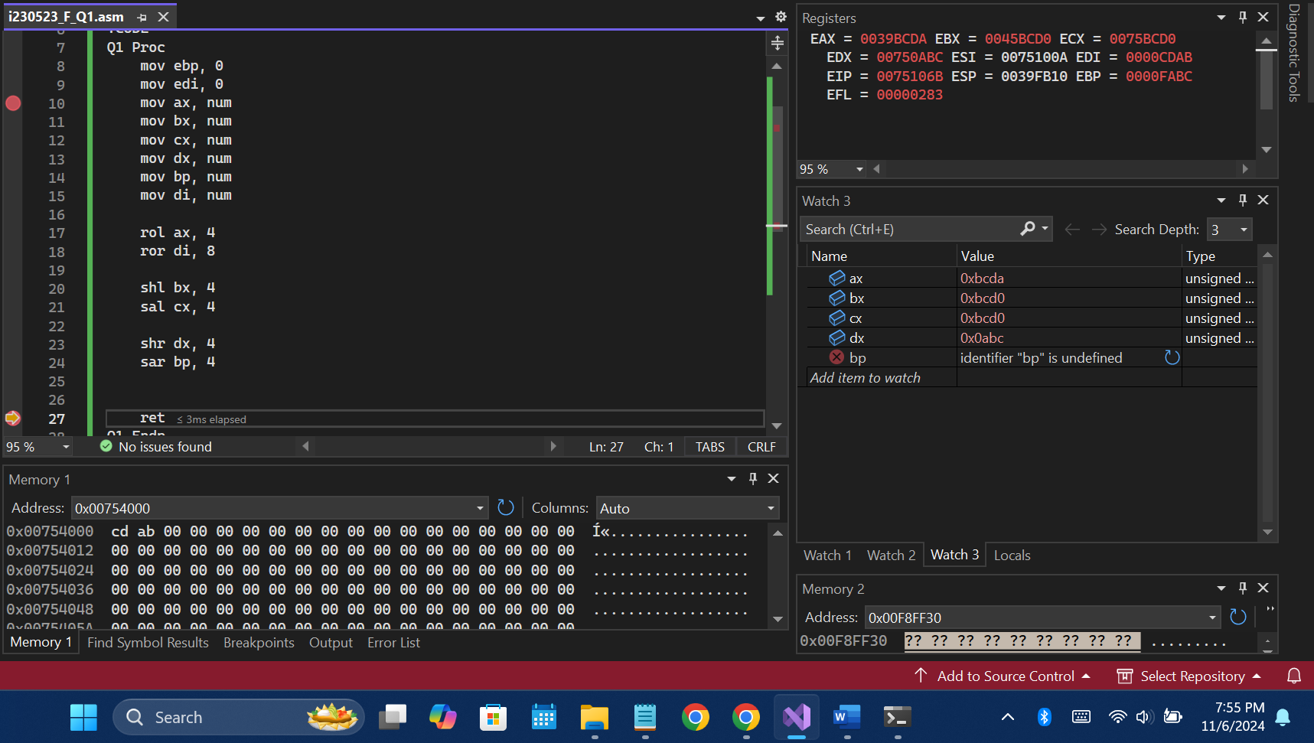
Rotate:
The rotate commands are only of one type and they simply rotate the bits without having any regards with their signs. So, there’s only ROL, ROR which is logical rotate and no arithmetic rotate.
Shift:
- Left Shift: Both arithmetic and logical left shifts are same.
- Right Shift: The arithmetic shift reserves the sign of number but the logical shift doesn’t reserves the sign and 0 just comes in place of that bit. (See dx and bp).
Task2:
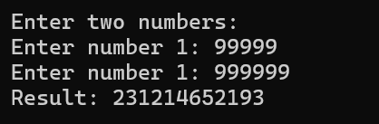
Q2 Proc
;Input;
mov edx, offset cstr1
call WriteString

mov edx, offset cstr2
call WriteString
mov eax, 0
call ReadInt
mov x1, eax

mov edx, offset cstr2
call WriteString
mov eax, 0
call ReadInt
mov x2, eax

;;;
mov eax, x1
mov edx, 0
imul x2

mov res1, edx
mov result, eax

;Output;
mov edx, offset cstr4
call WriteString
mov eax, res1
call WriteDec
mov eax, result
call WriteDec
call CrLf

ret
Q2 Endp
Task3:
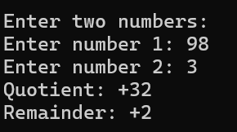
Q3 Proc
call takeinput

;Calculation;
mov eax, x1
mov edx, 0
idiv x2

mov res1, edx
mov result, eax

;Output;
mov edx, offset q3str1
call WriteString
mov eax, result
call WriteInt
call CrLf

mov edx, offset q3str2
call WriteString
mov eax, res1
call WriteInt
call CrLf

ret
Q3 Endp
Task4:
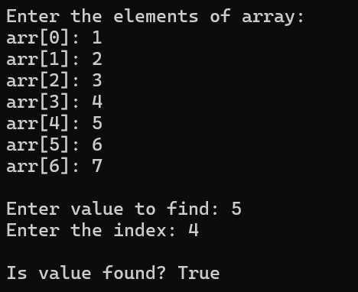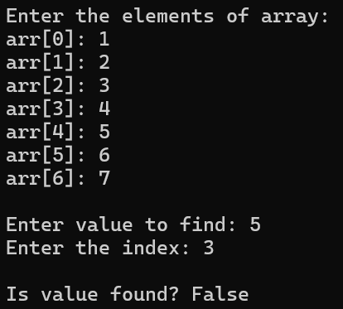
Q4 Proc
;Input;
mov edx, offset q4str1
call WriteString

mov ecx, arr4size
mov bl, 0
mov esi, offset arr4
L1:
mov edx, offset q4str2
call WriteString

mov eax, 0
mov al, bl
call WriteDec

mov edx, offset q4str3
call WriteString

mov eax, 0
call Readint
mov [esi], al

inc esi
inc bl
Loop L1

;Input-2;
mov edx, offset q4str4
call WriteString
mov eax, 0
call readInt
mov num4, al

mov edx, offset q4str5
call WriteString
mov eax, 0
call readInt
mov index4dd, eax
call Crlf

;Finding;
mov edx, offset q4str6
call Writestring

mov esi, offset arr4
add esi, index4dd
mov bl, [esi]
cmp bl, num4
je J1
jmp else1
J1:
mov edx, offset q4str7
jmp skip
else1:
mov edx, offset q4str8
skip:
call Writestring
call crlf

ret
Q4 Endp
Task5:
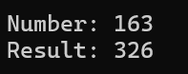
Q5 Proc
mov ax, 0
mov al, num5
mov res5, ax ; cf = 0
shl res5, 1 ; cf = 1
mov edx, offset q5str1
call Writestring
mov eax, 0
mov al, num5
call writedec
call Crlf

mov edx, offset cstr4
call Writestring
mov eax, 0
mov ax, res5
call writedec
call Crlf

ret
Q5 Endp
Task6:
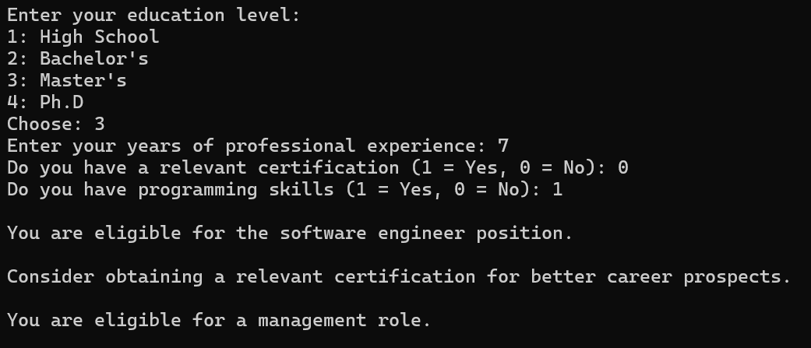
Q6 Proc
;---Input---;

mov edx, offset strinp1
call WriteString
mov eax, 0
call ReadInt
mov educationLevel, al

mov edx, offset strinp2
call WriteString
mov eax, 0
call ReadInt
mov yearsOfExperience, al

mov edx, offset strinp3
call WriteString
mov eax, 0
call ReadInt
mov hasRelevantCertification, al

mov edx, offset strinp4
call WriteString
mov eax, 0
call ReadInt
mov hasProgrammingSkills, ax

;--Checking Nested Conditions--;

mov al, educationLevel
mov bl, yearsOfExperience
mov cl, hasRelevantCertification
mov bp, hasProgrammingSkills

;IF
cmp al, 3
jb elseif11
cmp bl, 5
jb elseif11
cmp cl, 1
jne elseif11
cmp bp, 1
jne elseif11

mov edx, offset strif
jmp skip6

ELSEIF11:
cmp al, 2
jb elseif22
cmp bl, 3
jb elseif22
cmp bp, 1
jne elseif22

mov edx, offset strelseif1
jmp skip6

ELSEIF22:
cmp al, 2
jb elsee
cmp bl, 2
jb elsee

mov edx, offset strelseif2
jmp skip6

ELSEE:
mov edx, offset strelse

Skip6:
call Crlf
call WriteString
call Crlf

;;;;;
cmp cl, 1
jne elseee
;IFF
mov edx, offset striff
jmp skipp6
ELSEEE:
mov edx, offset strelsee
Skipp6:
call WriteString
call Crlf

;;;;;
cmp al, 3
jb endee
cmp bl, 7
jb endee

mov edx, offset strifff
call WriteString
call Crlf

ENDEE:

ret
Q6 Endp
Task7-10:
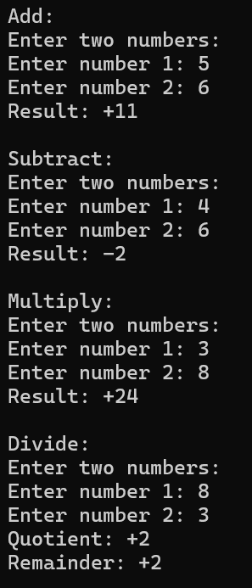
Q7 Proc
mov edx, offset op1
call Writestring

call takeinput

mov ebx, x1
add ebx, x2
mov result, ebx

call printoutput

ret
Q7 Endp

Q8 Proc
mov edx, offset op2
call Writestring

call takeinput

mov ebx, x1
sub ebx, x2
mov result, ebx

call printoutput

ret
Q8 Endp

Q9 Proc
call Q2

ret
Q9 Endp

Q10 Proc
call Q3

ret
Q10 Endp
Task11:
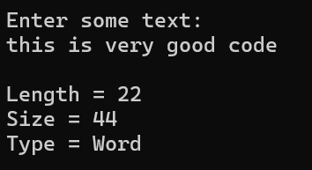
Q11 Proc
mov edx, offset stri
call Writestring
call Crlf

mov edx, offset str11
mov ecx, maxsize
call ReadString
call Crlf

;Length
mov ecx, maxsize
mov esi, offset str11
Ll:
mov bl, [esi]
cmp bl, 0
je exitl

inc esi
inc length11
Loop Ll
exitl:

;Size
mov al, type str11
mul length11
mov size11, al

;Type
mov al, type str11
mov ecx, 0

cmp al, 1
je jt1
cmp al, 2
je jt2
cmp al, 4
je jt3
cmp al, 8
je jt4

Jt1:
mov cl, lengthof t1
mov edi, offset t1
jmp skip11
Jt2:
mov cl, lengthof t2
mov edi, offset t2
jmp skip11
Jt3:
mov cl, lengthof t3
mov edi, offset t3
jmp skip11
Jt4:
mov cl, lengthof t4
mov edi, offset t4
jmp skip11

skip11:
mov esi, offset type11
Looop:
mov bl, [edi]
mov [esi], bl
inc esi
inc edi
Loop Looop

;Print;
mov edx, offset strl
call Writestring
mov eax, 0
mov al, length11
call WriteDec
call Crlf

mov edx, offset strs
call Writestring
mov eax, 0
mov al, size11
call WriteDec
call Crlf

mov edx, offset strt
call Writestring
mov edx, offset type11
call WriteString
call Crlf

ret
Q11 Endp

------------Code------------
include irvine32.inc

.DATA
op1 db "Add:", 0Ah, 0
op2 db "Subtract:", 0Ah, 0
op3 db "Multiply:", 0Ah, 0
op4 db "Divide:", 0Ah, 0

;-- Q1 --
num dw 0ABCDh

;-- Q2 --
cstr1 db "Enter two numbers: ", 0Ah, 0
cstr2 db "Enter number 1: ", 0
cstr3 db "Enter number 2: ", 0
cstr4 db "Result: ", 0
x1 dd ?
x2 dd ?
res1 dd 0
result dd 0

;-- Q3 --
q3str1 db "Quotient: ", 0
q3str2 db "Remainder: ", 0

;-- Q4 --
arr4size = 7
arr4 db arr4size dup(?)
index4 Label Byte
index4dd dd ?
num4 db ?

q4str1 db "Enter the elements of array: ", 0Ah, 0
q4str2 db "arr[", 0
q4str3 db "]: ", 0
q4str4 db 0Ah, "Enter value to find: ", 0
q4str5 db "Enter the index: ", 0
q4str6 db "Is value found? ", 0
q4str7 db "True", 0
q4str8 db "False", 0

;q4str1 db "Enter size of array (1-10)"

;-- Q5 --
q5str1 db "Number: ", 0
num5 db 10100011b
res5 dw ?

;-- Q6 --
educationLevel db ?
yearsOfExperience db ?
hasRelevantCertification db ?
hasProgrammingSkills dw ?

strinp1 db "Enter your education level:", 0Ah, "1: High School", 0Ah, "2: Bachelor's", 0Ah, "3: Master's", 0Ah, "4: Ph.D", 0Ah, "Choose: ", 0;
strinp2 db "Enter your years of professional experience: ", 0
strinp3 db "Do you have a relevant certification (1 = Yes, 0 = No): ", 0
strinp4 db "Do you have programming skills (1 = Yes, 0 = No): ", 0

strif db "Congratulations! You are eligible for the senior software engineer position.", 0Ah, 0
strelseif1 db "You are eligible for the software engineer position.", 0Ah, 0
strelseif2 db "You are eligible for the junior software engineer position.", 0Ah, 0
strelse db "Sorry, you are not eligible for any software engineering position at this time.", 0Ah, 0

striff db "You have a relevant certification.", 0Ah, 0
strelsee db "Consider obtaining a relevant certification for better career prospects.", 0Ah, 0

strifff db "You are eligible for a management role.", 0Ah, 0

;-- Q11 --
maxsize = 100
str11 dw maxsize dup(?)
stri db "Enter some text: ", 0
strl db "Length = ", 0
strs db "Size = ", 0
strt db "Type = ", 0
length11 db ?
size11 db ?
type11 db 20 dup(?)

t1 db "Byte", 0
t2 db "Word", 0
t3 db "Double Word", 0
t4 db "Quadword", 0

.CODE
Q1 Proc
mov ebp, 0
mov edi, 0
mov ax, num
mov bx, num
mov cx, num
mov dx, num
mov bp, num
mov di, num

rol ax, 4
ror di, 8

shl bx, 4
sal cx, 4

shr dx, 4
sar bp, 4

ret
Q1 Endp

takeinput Proc
;Input;
mov edx, offset cstr1
call WriteString

mov edx, offset cstr2
call WriteString
mov eax, 0
call ReadInt
mov x1, eax

mov edx, offset cstr3
call WriteString
mov eax, 0
call ReadInt
mov x2, eax

ret
takeinput Endp

Q2 Proc
mov edx, offset op3
call Writestring

call takeinput

;Calculation;
mov eax, x1
mov edx, 0
imul x2

mov res1, edx
mov result, eax

;Output;
mov edx, offset cstr4
call WriteString
;mov eax, res1
;call WriteInt
mov eax, result
call WriteInt
call CrLf
call CrLf

ret
Q2 Endp

Q3 Proc
mov edx, offset op4
call Writestring

call takeinput

;Calculation;
mov eax, x1
mov edx, 0
idiv x2

mov res1, edx
mov result, eax

;Output;
mov edx, offset q3str1
call WriteString
mov eax, result
call WriteInt
call CrLf

mov edx, offset q3str2
call WriteString
mov eax, res1
call WriteInt
call CrLf

ret
Q3 Endp

Q4 Proc
;Input;
mov edx, offset q4str1
call WriteString

mov ecx, arr4size
mov bl, 0
mov esi, offset arr4
L1:
mov edx, offset q4str2
call WriteString

mov eax, 0
mov al, bl
call WriteDec

mov edx, offset q4str3
call WriteString

mov eax, 0
call Readint
mov [esi], al

inc esi
inc bl
Loop L1

;Input-2;
mov edx, offset q4str4
call WriteString
mov eax, 0
call readInt
mov num4, al

mov edx, offset q4str5
call WriteString
mov eax, 0
call readInt
mov index4dd, eax
call Crlf

;Finding;
mov edx, offset q4str6
call Writestring

mov esi, offset arr4
add esi, index4dd
mov bl, [esi]
cmp bl, num4
je J1
jmp else1
J1:
mov edx, offset q4str7
jmp skip
else1:
mov edx, offset q4str8
skip:
call Writestring
call crlf

ret
Q4 Endp

Q5 Proc
clc
mov ax, 0
mov al, num5
mov res5, ax ; cf = 0
shl res5, 1 ; cf = 1

mov edx, offset q5str1
call Writestring
mov eax, 0
mov al, num5
call writedec
call Crlf

mov edx, offset cstr4
call Writestring
mov eax, 0
mov ax, res5
call writedec
call Crlf

ret
Q5 Endp

Q6 Proc
;---Input---;

mov edx, offset strinp1
call WriteString
mov eax, 0
call ReadInt
mov educationLevel, al

mov edx, offset strinp2
call WriteString
mov eax, 0
call ReadInt
mov yearsOfExperience, al

mov edx, offset strinp3
call WriteString
mov eax, 0
call ReadInt
mov hasRelevantCertification, al

mov edx, offset strinp4
call WriteString
mov eax, 0
call ReadInt
mov hasProgrammingSkills, ax

;--Checking Nested Conditions--;

mov al, educationLevel
mov bl, yearsOfExperience
mov cl, hasRelevantCertification
mov bp, hasProgrammingSkills

;IF
cmp al, 3
jb elseif11
cmp bl, 5
jb elseif11
cmp cl, 1
jne elseif11
cmp bp, 1
jne elseif11

mov edx, offset strif
jmp skip6

ELSEIF11:
cmp al, 2
jb elseif22
cmp bl, 3
jb elseif22
cmp bp, 1
jne elseif22

mov edx, offset strelseif1
jmp skip6

ELSEIF22:
cmp al, 2
jb elsee
cmp bl, 2
jb elsee

mov edx, offset strelseif2
jmp skip6

ELSEE:
mov edx, offset strelse

Skip6:
call Crlf
call WriteString
call Crlf

;;;;;
cmp cl, 1
jne elseee
;IFF
mov edx, offset striff
jmp skipp6
ELSEEE:
mov edx, offset strelsee
Skipp6:
call WriteString
call Crlf

;;;;;
cmp al, 3
jb endee
cmp bl, 7
jb endee

mov edx, offset strifff
call WriteString
call Crlf

ENDEE:

ret
Q6 Endp

printoutput Proc
mov edx, offset cstr4
call WriteString

mov eax, result
call WriteInt
call Crlf
call Crlf

ret
printoutput Endp

Q7 Proc
mov edx, offset op1
call Writestring

call takeinput

mov ebx, x1
add ebx, x2
mov result, ebx

call printoutput

ret
Q7 Endp

Q8 Proc
mov edx, offset op2
call Writestring

call takeinput

mov ebx, x1
sub ebx, x2
mov result, ebx

call printoutput

ret
Q8 Endp

Q9 Proc
call Q2

ret
Q9 Endp

Q10 Proc
call Q3

ret
Q10 Endp

Q11 Proc
mov edx, offset stri
call Writestring
call Crlf

mov edx, offset str11
mov ecx, maxsize
call ReadString
call Crlf

;Length
mov ecx, maxsize
mov esi, offset str11
Ll:
mov bl, [esi]
cmp bl, 0
je exitl

inc esi
inc length11
Loop Ll
exitl:

;Size
mov al, type str11
mul length11
mov size11, al

;Type
mov al, type str11
mov ecx, 0

cmp al, 1
je jt1
cmp al, 2
je jt2
cmp al, 4
je jt3
cmp al, 8
je jt4

Jt1:
mov cl, lengthof t1
mov edi, offset t1
jmp skip11
Jt2:
mov cl, lengthof t2
mov edi, offset t2
jmp skip11
Jt3:
mov cl, lengthof t3
mov edi, offset t3
jmp skip11
Jt4:
mov cl, lengthof t4
mov edi, offset t4
jmp skip11

skip11:
mov esi, offset type11
Looop:
mov bl, [edi]
mov [esi], bl
inc esi
inc edi
Loop Looop

;Print;
mov edx, offset strl
call Writestring
mov eax, 0
mov al, length11
call WriteDec
call Crlf

mov edx, offset strs
call Writestring
mov eax, 0
mov al, size11
call WriteDec
call Crlf

mov edx, offset strt
call Writestring
mov edx, offset type11
call WriteString
call Crlf

ret
Q11 Endp

main Proc
;call Q1

;call Q2

;call Q3

;call Q4

;call Q5

call Q6

;call Q7

;call Q8

;call Q9

;call Q10

;call Q11

Invoke ExitProcess, 0
main Endp
End main

